**Classroom Activity: Apply Structure or proper layout to portfolio website**

**Code:**

**Index.html**

|  |
| --- |
| <!DOCTYPE html>  <html lang="en">  <head>  <meta charset="UTF-8">  <meta name="viewport" content="width=device-width, initial-scale=1.0">  <title>Karan Bhat Portfolio</title>  <link rel="stylesheet" href="styles.css">  </head>  <body>  <header>  <nav>  <ul>  <li><a href="index.html">Home</a></li>  <li><a href="portfolio.html">Portfolio</a></li>  <li><a href="contact.html">Contact</a></li>  <li><a href="about.html">About</a></li>  </ul>  </nav>  </header>  <section>  <article>  <h2>Karan Bhat Portfolio</h2>  <p>Karan Bhat is a skilled technical trainer with extensive experience in teaching and mentoring. He specializes in various programming languages and web development technologies. Known for his clear explanations and practical approach, Karan has successfully guided many students through complex technical concepts. His passion for technology and dedication to student success make him a valuable asset in the educational field. Karan continuously updates his knowledge to provide the most current and relevant training to his students.</p>  </article>    <aside>  <h3>Quick Links</h3>  <ul>  <li><a href="portfolio.html">My Projects</a></li>  <li><a href="about.html">About Me</a></li>  </ul>  </aside>  <figure>  <img src="images/pexels-pixabay-301920.jpg" width="400px" height="200px" alt="Study">  <figcaption>Karan Do Hard Work Please</figcaption>  </figure>  <video controls>  <source src="videos/2278095-hd_1920_1080_30fps.mp4" type="video/mp4">  Your browser does not support the video tag.  </video>  <table>  <caption>Academic Qualifications</caption>  <thead>  <tr>  <th>Qualification</th>  <th>Percentage/CGPA</th>  </tr>  </thead>  <tbody>  <tr>  <td>10th</td>  <td>60%</td>  </tr>  <tr>  <td>12th</td>  <td>60%</td>  </tr>  <tr>  <td>B.E. Computer Science</td>  <td>6.2 CGPA</td>  </tr>  </tbody>  </table>  </section>    </body>  </html> |

**Portfolio.html:**

|  |
| --- |
| <!DOCTYPE html>  <html lang="en">  <head>  <meta charset="UTF-8">  <meta name="viewport" content="width=device-width, initial-scale=1.0">  <title>Portfolio</title>  <link rel="stylesheet" href="styles.css">  </head>  <body>  <header>  <nav>  <ul>  <li><a href="index.html">Home</a></li>  <li><a href="portfolio.html">Portfolio</a></li>  <li><a href="contact.html">Contact</a></li>  <li><a href="about.html">About</a></li>  </ul>  </nav>  </header>  <section>  <article>  <h2>My Projects</h2>  <div class="projects-grid">  <div class="project">  <img src="images/gfg.png" alt="Abhiyantrik Shikshas" width="100">  <h1>Abhiyantrik Shikshas</h1>  <p>"Abhiyantrik Shikshas" is an educational initiative aimed at enhancing technical skills and knowledge among students and professionals. This project focuses on providing high-quality training and resources in various fields of engineering and technology, with an emphasis on practical and industry-relevant skills.</p>  </div>  <div class="project">  <img src="images/emp_detail_master.png" alt="Employee Management" width="100">  <h1>Employee Management</h1>  <p>The Employee Management System (EMS) is a comprehensive software solution designed to streamline and automate various aspects of employee administration within an organization. This system helps manage employee information, track performance, handle payroll, and ensure compliance with employment laws. By centralizing employee data and processes, EMS enhances efficiency, accuracy, and productivity in human resources (HR) departments.</p>  </div>  </div>  </article>  </section>  <footer>  <p>&copy; 2024 Your Name. All rights reserved.</p>  </footer>  </body>  </html> |

**About.html:**

|  |
| --- |
| <!DOCTYPE html>  <html lang="en">  <head>  <meta charset="UTF-8">  <meta name="viewport" content="width=device-width, initial-scale=1.0">  <title>About</title>  <link rel="stylesheet" href="styles.css">  </head>  <body>  <header>  <nav>  <ul>  <li><a href="index.html">Home</a></li>  <li><a href="portfolio.html">Portfolio</a></li>  <li><a href="contact.html">Contact</a></li>  <li><a href="about.html">About</a></li>  </ul>  </nav>  </header>  <section>  <article>  <h2>About Me</h2>  <p id="a">Karan Bhat is a skilled technical trainer with five years of experience in the industry and is currently working with Edunet. He has extensive experience in teaching and mentoring, specializing in various programming languages and web development technologies. Known for his clear explanations and practical approach, Karan has successfully guided many students through complex technical concepts. His passion for technology and dedication to student success make him a valuable asset in the educational field. At Edunet, Karan continuously updates his knowledge to provide the most current and relevant training to his students. He emphasizes hands-on learning and real-world applications to ensure his students are well-prepared for their careers. Karan's ability to break down difficult topics into understandable segments has earned him high praise from both beginners and advanced learners. His commitment to excellence and student-centric teaching methods reflect his dedication to fostering the next generation of tech professionals. As a trusted mentor, Karan continues to inspire and equip his students with the skills needed to thrive in the ever-evolving tech industry.</p>  <blockquote>  "Karan Bhat is a technical trainer working at Edunet Foundation as a Master Trainer."  <cite>Edunet Foundation</cite>  </blockquote>    </article>  </section>  <footer>  <p>&copy; 2024 Your Name. All rights reserved.</p>  </footer>  </body>  </html> |

**Contact.html:**

|  |
| --- |
| <!DOCTYPE html>  <html lang="en">  <head>  <meta charset="UTF-8">  <meta name="viewport" content="width=device-width, initial-scale=1.0">  <title>Contact</title>  <link rel="stylesheet" href="styles.css">  </head>  <body>  <header>  <nav>  <ul>  <li><a href="index.html">Home</a></li>  <li><a href="portfolio.html">Portfolio</a></li>  <li><a href="contact.html">Contact</a></li>  <li><a href="about.html">About</a></li>  </ul>  </nav>  </header>  <section>  <article>  <h2>Contact Me</h2>  <form action="submit_form.php" method="post">  <label for="name">Name:</label>  <input type="text" id="name" name="name">  <br>  <label for="message">Message:</label>  <textarea id="message" name="message"></textarea>  <br>  <br>  <button type="submit">Submit</button>  <br>  </form>  </article>  </section>  <footer>  <p>&copy; 2024 Your Name. All rights reserved.</p>  </footer>  </body>  </html> |

**Output:**

**Home:**

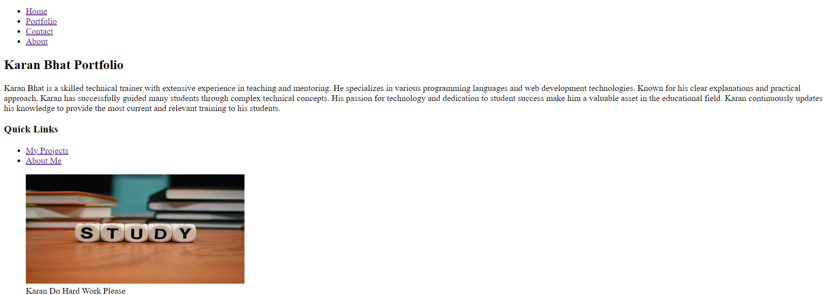

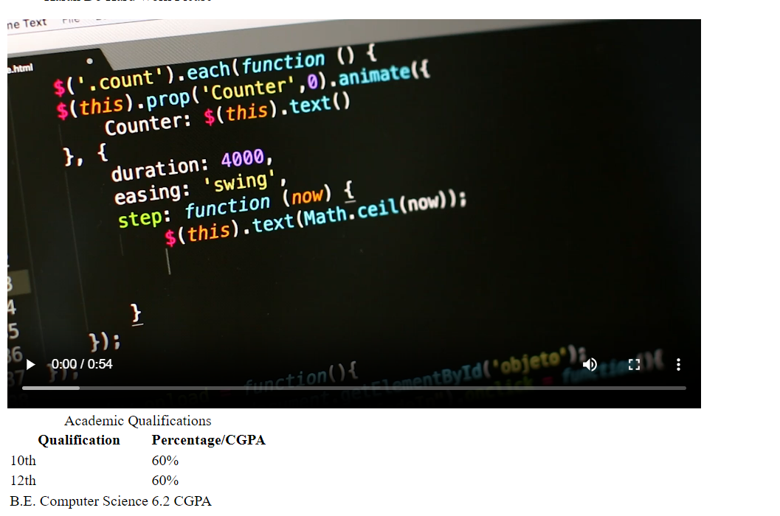

**Portfolio:**

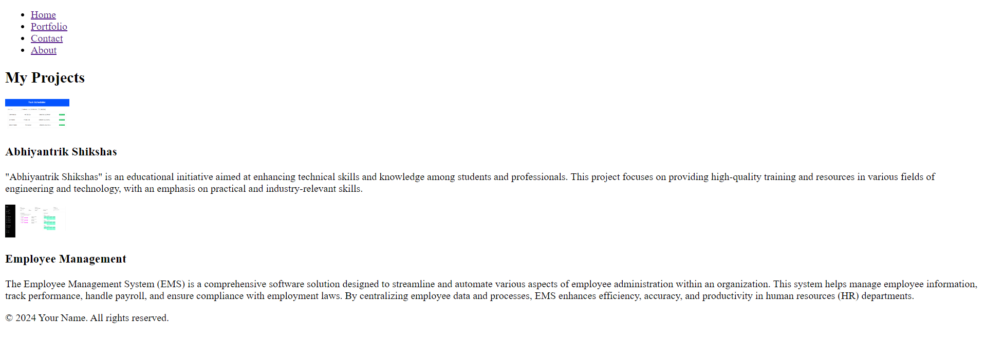

**About:**

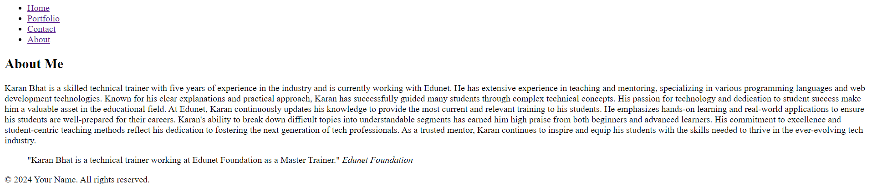

**Contact:**

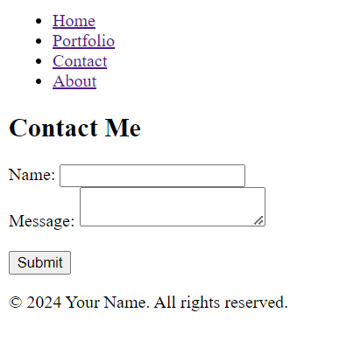

**Execution Steps:**

* Step 1: Set Up Your Project Directory

Open Visual Studio Code.

Create a new folder for your project, e.g., PortfolioProject.

* Step 2: Create the Basic File Structure

Inside your project folder, create the following files and folders:

PortfolioProject/

│

├── index.html

├── portfolio.html

├── contact.html

├── about.html

├── style.css

* Step 3: Click on Go Live.
* Step 4: Then it automatically takes up to the browser page.
* Step 5: Select Inspect
* Step 6: Get the idea of the code.